Ye MySQL database error hai. Iska matlab hai ke jo value role column me insert ho rahi hai, woh database ke expected format se match nahi kar rahi.
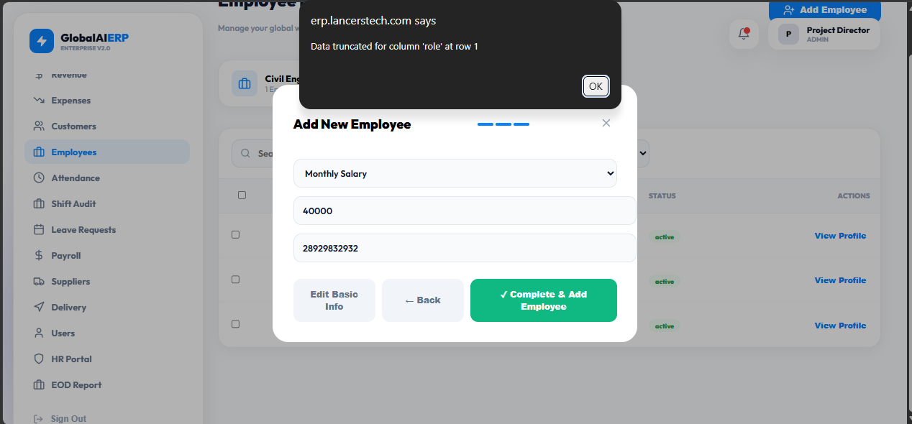

Isma date bhai add kero
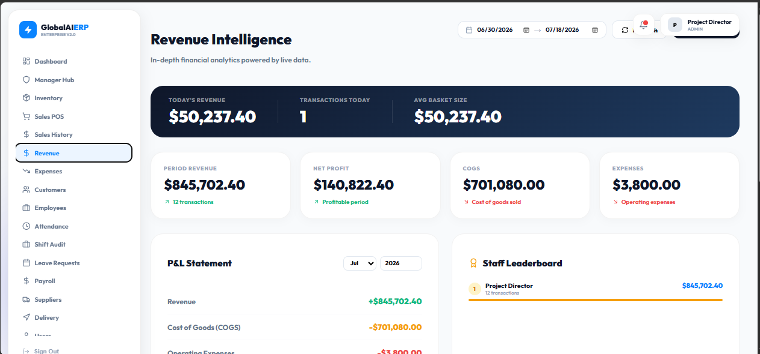

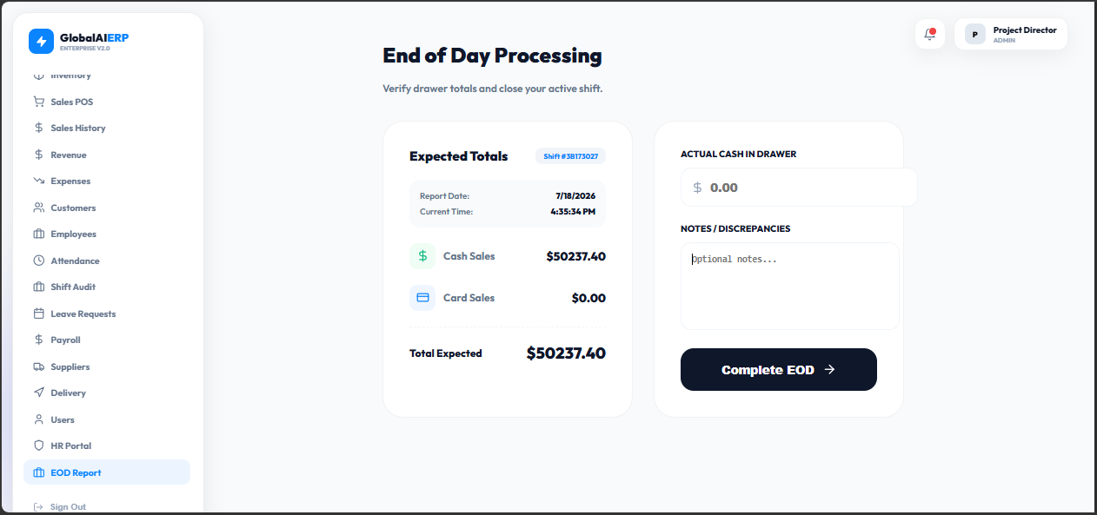

Database ma add nhai hoi or udher/credit ki jaga loan/credit likho
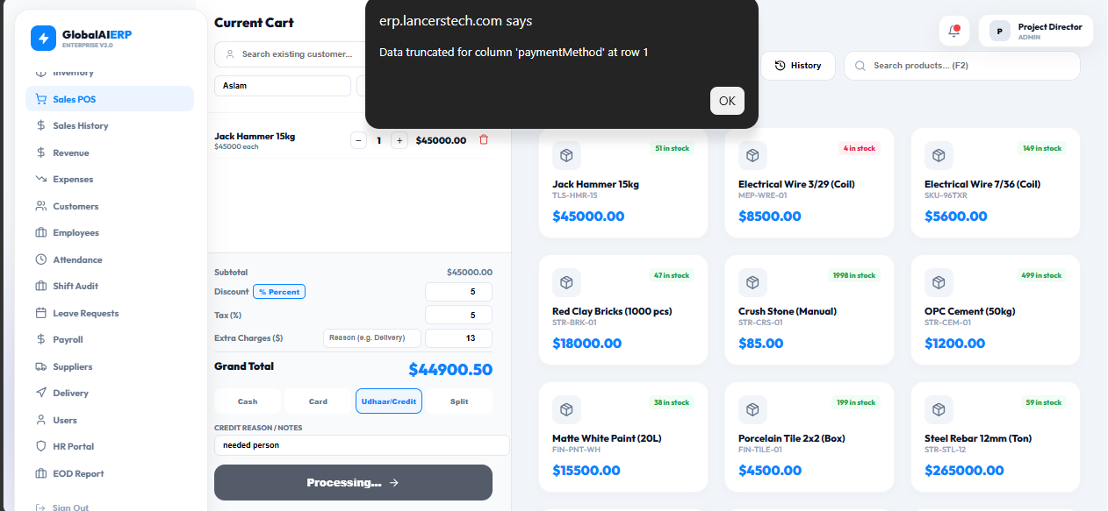

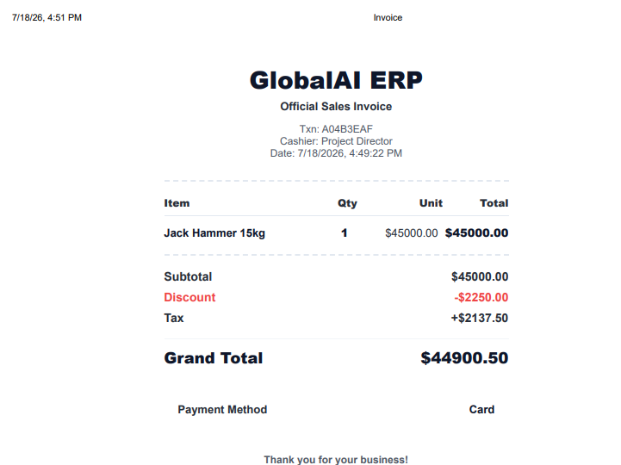
Original print global ai ERP ha or cashier :project director ha lakin reprint ma cashier :project director nhai show ho rha us ma bhi add kero or Enterprise remove ker ka Global ai ERP add kero

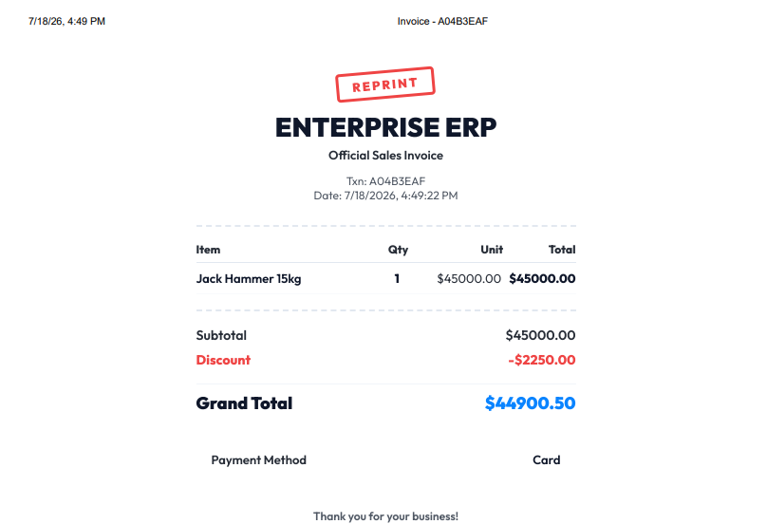



Is ma ya jo current wala ha is ma screen ko skretch kera ga jo ma red colour sa ovel draw kia ha
Or pink wala underline kia ha isma jab screen ko skretch kera to sub total ,discount ,tax wala or etc abhi ya column ma ha to jab screen ko skretch ya row ma hojai or jo right side ma green colour sa underline kia ha us ma jo items ha wo minimize hogai jab screen ko skretch kero

or jo system ma apna bill generate ker rha ha wo apna name bhai lakha ya bhi

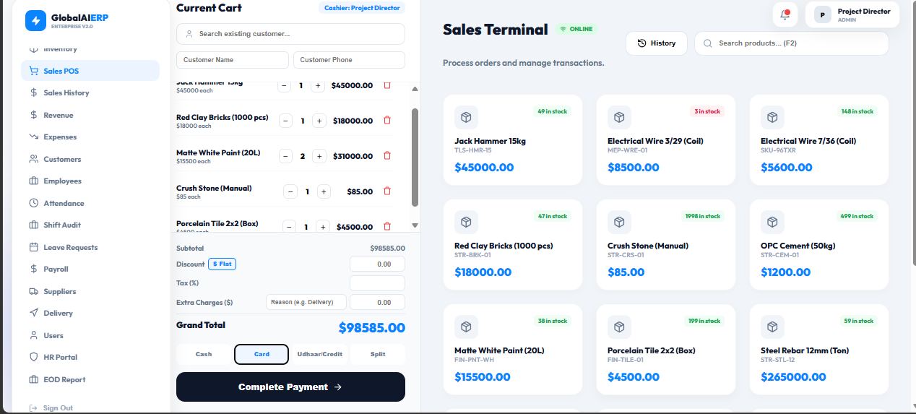

Salary calculate per hour system pay auto .Calculate monthly optional in which when duty time off it automatically not count pay after duty hours (decide duty hours)

